# Module 4 - Assignment 2

## Amanda Odum

drug <- read_csv("drug_data-1.csv")

## Rows: 1885 Columns: 32

## ── Column specification ────────────────────────────────────────────────────────  
## Delimiter: ","  
## chr (19): Column14, Column15, Column16, Column17, Column18, Column19, Column...  
## dbl (13): Column1, Column2, Column3, Column4, Column5, Column6, Column7, Col...

##   
## ℹ Use `spec()` to retrieve the full column specification for this data.  
## ℹ Specify the column types or set `show_col_types = FALSE` to quiet this message.

names(drug) = c("ID", "Age", "Gender", "Education", "Country", "Ethnicity",  
"Nscore", "Escore", "Oscore", "Ascore", "Cscore", "Impulsive",  
"SS", "Alcohol", "Amphet", "Amyl", "Benzos", "Caff", "Cannabis",  
"Choc", "Coke", "Crack", "Ecstasy", "Heroin", "Ketamine", "Legalh",  
"LSD", "Meth", "Mushrooms", "Nicotine", "Semer", "VSA")  
#str(drug)  
  
drug[drug == "CL0"] = "No"  
drug[drug == "CL1"] = "No"  
drug[drug == "CL2"] = "Yes"  
drug[drug == "CL3"] = "Yes"  
drug[drug == "CL4"] = "Yes"  
drug[drug == "CL5"] = "Yes"  
drug[drug == "CL6"] = "Yes"  
  
drug_clean = drug %>% mutate_at(vars(Age:Ethnicity), funs(as_factor)) %>%  
mutate(Age = factor(Age, labels = c("18_24", "25_34", "35_44",  
"45_54", "55_64", "65_"))) %>%  
mutate(Gender = factor(Gender, labels = c("Male", "Female"))) %>%  
mutate(Education = factor(Education, labels =  
c("Under16", "At16", "At17", "At18", "SomeCollege",  
"ProfessionalCert", "Bachelors", "Masters", "Doctorate"))) %>%  
mutate(Country = factor(Country,  
labels = c("USA", "NewZealand", "Other", "Australia",  
"Ireland","Canada","UK"))) %>%  
mutate(Ethnicity = factor(Ethnicity,  
labels = c("Black", "Asian", "White", "White/Black", "Other",  
"White/Asian", "Black/Asian"))) %>% mutate_at(vars(Alcohol:VSA), funs(as_factor)) %>%  
select(-ID)

## Warning: `funs()` was deprecated in dplyr 0.8.0.  
## Please use a list of either functions or lambdas:   
##   
## # Simple named list:   
## list(mean = mean, median = median)  
##   
## # Auto named with `tibble::lst()`:   
## tibble::lst(mean, median)  
##   
## # Using lambdas  
## list(~ mean(., trim = .2), ~ median(., na.rm = TRUE))  
## This warning is displayed once every 8 hours.  
## Call `lifecycle::last_lifecycle_warnings()` to see where this warning was generated.

#str(drug_clean)  
  
drug_clean = drug_clean %>% select(!(Alcohol:Mushrooms)) %>% select(!(Semer:VSA))  
names(drug_clean)

## [1] "Age" "Gender" "Education" "Country" "Ethnicity" "Nscore"   
## [7] "Escore" "Oscore" "Ascore" "Cscore" "Impulsive" "SS"   
## [13] "Nicotine"

#summary(drug_clean)

**Task 1**

skim(drug_clean)

Data summary

|  |  |
| --- | --- |
| Name | drug_clean |
| Number of rows | 1885 |
| Number of columns | 13 |
| _______________________ |  |
| Column type frequency: |  |
| factor | 6 |
| numeric | 7 |
| ________________________ |  |
| Group variables | None |

**Variable type: factor**

| skim_variable | n_missing | complete_rate | ordered | n_unique | top_counts |
| --- | --- | --- | --- | --- | --- |
| Age | 0 | 1 | FALSE | 6 | 18_: 643, 25_: 481, 35_: 356, 45_: 294 |
| Gender | 0 | 1 | FALSE | 2 | Mal: 943, Fem: 942 |
| Education | 0 | 1 | FALSE | 9 | Som: 506, Bac: 480, Mas: 283, Pro: 270 |
| Country | 0 | 1 | FALSE | 7 | UK: 1044, USA: 557, Oth: 118, Can: 87 |
| Ethnicity | 0 | 1 | FALSE | 7 | Whi: 1720, Oth: 63, Bla: 33, Asi: 26 |
| Nicotine | 0 | 1 | FALSE | 2 | Yes: 1264, No: 621 |

**Variable type: numeric**

| skim_variable | n_missing | complete_rate | mean | sd | p0 | p25 | p50 | p75 | p100 | hist |
| --- | --- | --- | --- | --- | --- | --- | --- | --- | --- | --- |
| Nscore | 0 | 1 | 0.00 | 1.00 | -3.46 | -0.68 | 0.04 | 0.63 | 3.27 | ▁▃▇▅▁ |
| Escore | 0 | 1 | 0.00 | 1.00 | -3.27 | -0.70 | 0.00 | 0.64 | 3.27 | ▁▃▇▃▁ |
| Oscore | 0 | 1 | 0.00 | 1.00 | -3.27 | -0.72 | -0.02 | 0.72 | 2.90 | ▁▃▇▆▁ |
| Ascore | 0 | 1 | 0.00 | 1.00 | -3.46 | -0.61 | -0.02 | 0.76 | 3.46 | ▁▃▇▃▁ |
| Cscore | 0 | 1 | 0.00 | 1.00 | -3.46 | -0.65 | -0.01 | 0.58 | 3.46 | ▁▃▇▃▁ |
| Impulsive | 0 | 1 | 0.01 | 0.95 | -2.56 | -0.71 | -0.22 | 0.53 | 2.90 | ▁▆▇▃▁ |
| SS | 0 | 1 | 0.00 | 0.96 | -2.08 | -0.53 | 0.08 | 0.77 | 1.92 | ▂▇▇▇▅ |

*No data is missing.*

**Task 2**

set.seed(1234)   
drug_clean_split = initial_split(drug_clean, prop = 0.7, strata = Nicotine) #70% in training  
train = training(drug_clean_split)  
test = testing(drug_clean_split)

**Task 3**

p1 = ggplot(train, aes(x = Age, fill = Nicotine)) + geom_bar(position = "fill") + theme(axis.text.x = element_text(angle = 60, hjust = 1))  
p2 = ggplot(train, aes(x = Gender, fill = Nicotine)) + geom_bar(position = "fill") + theme(axis.text.x = element_text(angle = 60, hjust = 1))  
p3 = ggplot(train, aes(x = Education, fill = Nicotine)) + geom_bar(position = "fill") + theme(axis.text.x = element_text(angle = 60, hjust = 1))  
p4 = ggplot(train, aes(x = Country, fill = Nicotine)) + geom_bar(position = "fill") + theme(axis.text.x = element_text(angle = 60, hjust = 1))  
grid.arrange(p1,p2,p3,p4)

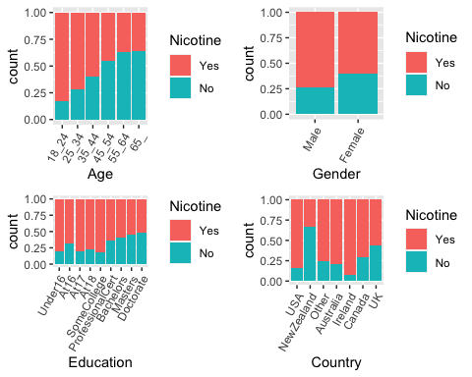

p5 = ggplot(train, aes(x = Ethnicity, fill = Nicotine)) + geom_bar(position = "fill")+ theme(axis.text.x = element_text(angle = 60, hjust = 1))  
p6 = ggplot(train, aes(x = Nicotine, y = Nscore)) + geom_boxplot()  
p7 = ggplot(train, aes(x = Nicotine, y = Escore)) + geom_boxplot()  
p8 = ggplot(train, aes(x = Nicotine, y = Oscore)) + geom_boxplot()  
grid.arrange(p5, p6, p7, p8)

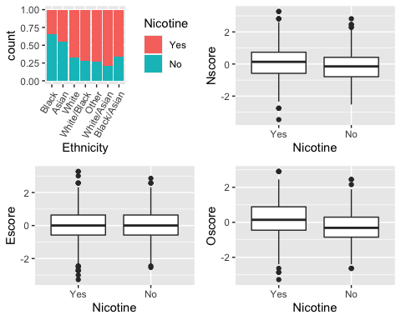

p9 = ggplot(train, aes(x = Nicotine, y = Ascore)) + geom_boxplot()  
p10 = ggplot(train, aes(x = Nicotine, y = Cscore)) + geom_boxplot()  
p11 = ggplot(train, aes(x = Nicotine, y = Impulsive)) + geom_boxplot()  
p12 = ggplot(train, aes(x = Nicotine, y = SS)) + geom_boxplot()  
grid.arrange(p9, p10, p11, p12)

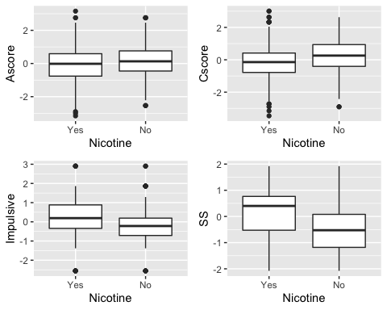

*Nicotine usage appears to drop continually as age increases. Females appear ~1.5 times less likely to use nicotine than males. Nicotine usage appears to be negatively correlated with education levels, as it goes down as education level increases. Nicotine usage is highest in the US and Ireland, and lowest in the UK and New Zealand. People who identify as black and Asian appear less likely to use nicotine than other races. Nicotine users have higher Nscore, Oscore, Impulsive,and SS values. Nicotine users have lower Ascore and Cscore values, and have roughtly the same Escore values as those who do not use nicotine.*

**Task 4**

set.seed(123)  
rf_folds = vfold_cv(train, v = 5)  
  
drug_recipe = recipe(Nicotine ~., train) %>%  
 step_dummy(all_nominal(), -all_outcomes())  
  
rf_model = rand_forest(mtry = tune(), min_n = tune(), trees = 100) %>%   
 set_engine("ranger", importance = "permutation") %>% #added importance metric  
 set_mode("classification")  
  
drug_wflow =   
 workflow() %>%   
 add_model(rf_model) %>%   
 add_recipe(drug_recipe)  
  
rf_grid = grid_regular(  
 mtry(range = c(2, 8)),   
 min_n(range = c(5, 20)),   
 levels = 10  
)  
  
set.seed(123)  
rf_res_tuned = tune_grid(  
 drug_wflow,  
 resamples = rf_folds,  
 grid = rf_grid #use the tuning grid  
)

rf_res_tuned %>%  
 collect_metrics() %>%  
 filter(.metric == "accuracy") %>%  
 select(mean, min_n, mtry) %>%  
 pivot_longer(min_n:mtry,  
 values_to = "value",  
 names_to = "parameter"  
 ) %>%  
 ggplot(aes(value, mean, color = parameter)) +  
 geom_point(show.legend = FALSE) +  
 facet_wrap(~parameter, scales = "free_x") +  
 labs(x = NULL, y = "Accuracy")

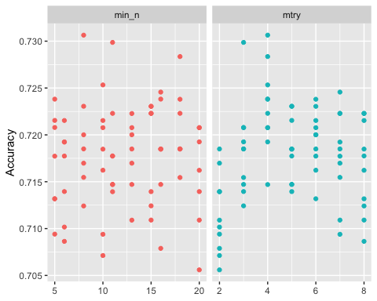

rf_res_tuned %>%  
 collect_metrics() %>%  
 filter(.metric == "accuracy") %>%  
 mutate(min_n = factor(min_n)) %>%  
 ggplot(aes(mtry, mean, color = min_n)) +  
 geom_line(alpha = 0.5, size = 1.5) +  
 geom_point() +  
 labs(y = "Accuracy")

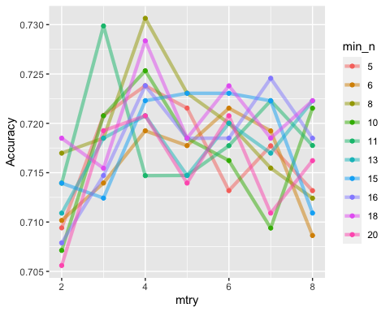

**Task 5**

best_rf = select_best(rf_res_tuned, "accuracy")  
  
final_rf = finalize_workflow(  
 drug_wflow,  
 best_rf  
)  
  
final_rf

## ══ Workflow ════════════════════════════════════════════════════════════════════  
## Preprocessor: Recipe  
## Model: rand_forest()  
##   
## ── Preprocessor ────────────────────────────────────────────────────────────────  
## 1 Recipe Step  
##   
## • step_dummy()  
##   
## ── Model ───────────────────────────────────────────────────────────────────────  
## Random Forest Model Specification (classification)  
##   
## Main Arguments:  
## mtry = 4  
## trees = 100  
## min_n = 8  
##   
## Engine-Specific Arguments:  
## importance = permutation  
##   
## Computational engine: ranger

final_rf_fit = fit(final_rf, train)

**Task 6**

trainpredrf = predict(final_rf_fit, train)  
head(trainpredrf)

## # A tibble: 6 × 1  
## .pred_class  
## <fct>   
## 1 No   
## 2 No   
## 3 No   
## 4 No   
## 5 No   
## 6 No

confusionMatrix(trainpredrf$.pred_class, train$Nicotine, positive = "Yes")

## Confusion Matrix and Statistics  
##   
## Reference  
## Prediction Yes No  
## Yes 879 78  
## No 5 356  
##   
## Accuracy : 0.937   
## 95% CI : (0.9225, 0.9495)  
## No Information Rate : 0.6707   
## P-Value [Acc > NIR] : < 2.2e-16   
##   
## Kappa : 0.8511   
##   
## Mcnemar's Test P-Value : 2.722e-15   
##   
## Sensitivity : 0.9943   
## Specificity : 0.8203   
## Pos Pred Value : 0.9185   
## Neg Pred Value : 0.9861   
## Prevalence : 0.6707   
## Detection Rate : 0.6669   
## Detection Prevalence : 0.7261   
## Balanced Accuracy : 0.9073   
##   
## 'Positive' Class : Yes   
##

testpredrf = predict(final_rf_fit, test)  
head(testpredrf)

## # A tibble: 6 × 1  
## .pred_class  
## <fct>   
## 1 Yes   
## 2 Yes   
## 3 No   
## 4 No   
## 5 Yes   
## 6 Yes

confusionMatrix(testpredrf$.pred_class, test$Nicotine, positive = "Yes")

## Confusion Matrix and Statistics  
##   
## Reference  
## Prediction Yes No  
## Yes 332 115  
## No 48 72  
##   
## Accuracy : 0.7125   
## 95% CI : (0.6733, 0.7495)  
## No Information Rate : 0.6702   
## P-Value [Acc > NIR] : 0.01708   
##   
## Kappa : 0.2846   
##   
## Mcnemar's Test P-Value : 2.347e-07   
##   
## Sensitivity : 0.8737   
## Specificity : 0.3850   
## Pos Pred Value : 0.7427   
## Neg Pred Value : 0.6000   
## Prevalence : 0.6702   
## Detection Rate : 0.5855   
## Detection Prevalence : 0.7884   
## Balanced Accuracy : 0.6294   
##   
## 'Positive' Class : Yes   
##

*The model performs much better on the training set than on the testing set.*

**Task 7**

*This model could be used by insurance companies (life or health) to deny coverage and/or increase premiums or by a clinician or healthcare organization to make healthcare decisions on things such as clinical trial or organ transplant on an individual. I would not recommend this model for real world use as its accuracy on the testing set was only 61.5%. My concern would be that this could incorrectly classify an individual as a smoker/nicotine user and prevent them from receiving appropriate care or coverage based on factors such as age, location, education, et cetera.*